1. **The anatomy of the microscope**

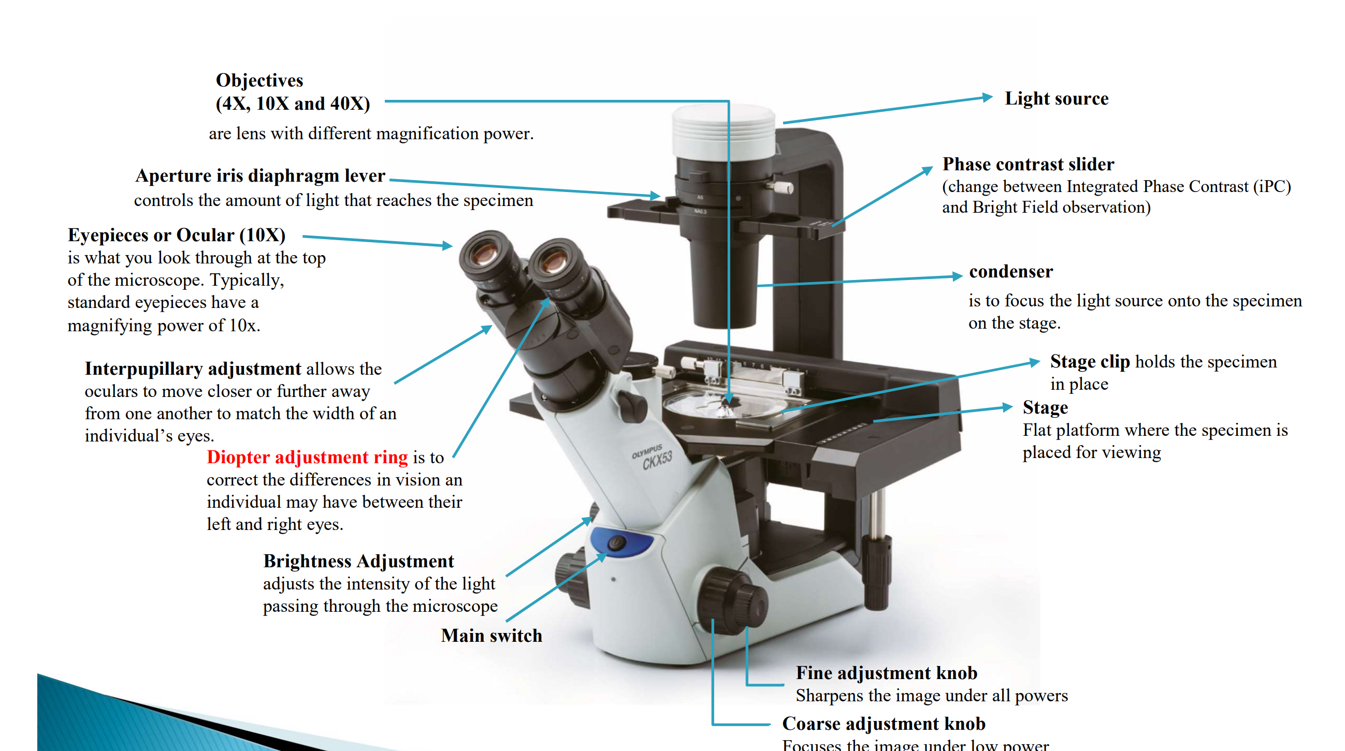

1. **Bright field and phase contrast microscope**

**Illumination techniques**

1. **Bright field**

* sample illumination is transmitted **white light** and contrast in the sample is caused by absorbance of some of the transmitted light in dense areas of the sample.
* The technique is more useful with specimens **stained with visible light absorbing dyes (such as eosin and hematoxylin).**

1. **Phase contrast**

* Phase contrast microscopy converts phase shifts in light passing through a **transparent specimen** to **brightness changes in image**
* It enables the visualization of living cells, unstained cells and various cell organelles



1. **Use a microscope**

* Your microscope is **parcentric and parfocal** （par=equal）
* **Parcentric**: This means that an object in the center of the field of view at one magnification is **in the center of the field of view at any of the other magnifications.**
* **Parfocal:** A microscope that is “parfocal” is one which, **if it is in focus with one objective,** when the objective is rotated, **will remain (mostly) in focus**
* If necessary, the lenses should be cleaned with lens paper (but not paper towel!).
* Always slide the lower objective into place and lower the stage, before inserting a microscope slide. As a general rule, you should start focusing with the 10X objective unless the large size of the object requires starting with the 4X objective
* the image is inverted.
* NEVER use the **coarse adjustment knob** to focus the objective when you are using 40X or higher-power objectives.
* **Total magnification = the power of the objective (4X, 10X, 40X…) multiply by the power of the eyepiece (usually 10X),**
* Adjusting the Interpupillary Distance. Focus on the specimen and slide the eyepieces closer together or farther apart by adjusting the eye tubes until the two fields merge to form a single circle.
* **Diopter Adjustment**

first close the eye over the eyepiece with the diopter adjustment and normally focus the microscope so that the open eye sees the image in focus. Next, switch eyes (close the open eye, open the closed eye) and without changing the main focus knobs, focus on the image by turning the diopter adjustment only.

1. **Cells and cells staining**

* **Human blood smea**r (contains erythrocytes, leukocytes and platelets)
* **Wright-Giemsa Stain** (oxidized methylene blue, azure B and eosin Y dyes) ◦ specifically intended to stain human blood cells
* 
* **H9c2 cells** (a permanent cell line derived from embryonic BD1X rat heart tissue)
* **Hematoxylin-eosin Stain** commonly used to stain tissue sections on microscope slides.
* **eosin stains cytoplasm (appears as pale pink)/hematoxylin stains nucleus (appears as purple)**

1. **Hemocytometer**

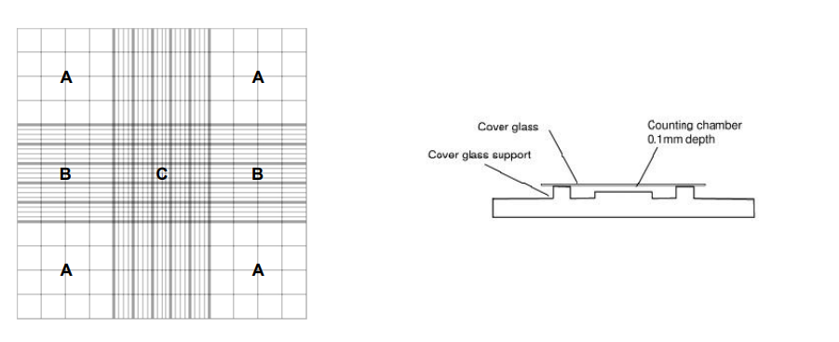



* Each counting area has 9 large squares (see Figure 3). In the figure:

A is a large square with 16 small squares;

B is a large square with 20 small squares, each with 4 rectangles;

C is a large square with 25 small squares, each with 16 smaller squares.

* each large square is equal to precisely 10-4 ml (equivalent to 0.1 ul). If 30 cells were located in one large square, then your sample would contain 30 x 10^4 cells/ml.
* To check on accuracy, the numbers from several squares are obtained. If they are

close, they can be averaged. If the numbers are far apart, the hemocytometer should be cleaned and reloaded. A comparison of the numbers from several loadings should be made

**A**. **How to focus**

1. With a piece of lens paper, **clean the eyepieces** and objectives.

2. Slide the **lower power objective** into place.

3**. Place a specimen** on the microscope stage.

4. **Watching from the side** and being careful not to drive the objective into the coverslip,

**lower the objective** as far as you can.

5. Viewing through the eyepieces, **focus up (raise the objective)** until a semblance of the

specimen is seen.

6. Adjust the iris **diaphragm,** filter size or light control to optimize the **lighting.**

7. With a bit of fine focusing, you are all set.

**B．Measuring the field size by stage micrometer**

1. With the 40X objective engaged, **place stage micrometer** (a short and transparent

ruler) over the opening in the center of the stage so that the lines are visible through

the microscope.

2. **Move the ruler** so that a **horizontal millimeter (mm) mark** is just visible at the **top edge**

of the circular field of view.

3. **Count the number of millimeters** from the top to the bottom point. If the top point of

the field does not line up with one of the horizontal markings, estimate the fraction of

a millimeter. This is the diameter of the 400X field of view. **Record your measurement**

**in millimeters (mm) and in micrometers (um) on the Datasheet (P.8).** Note that the

diameter of the field is less than 1 mm.

4. **Calculate the diameter of the 100X field** by the following equation:

diameter of the high power field/ diameter of the low power field

= low power magnification/ high power magnification

**C．Calibration of ocular micrometer and measuring cell length or diameter**

1**. Place an ocular micromete**r in the eyepiece of the microscope, according to the

instructions of TAs or technician.

2. **Put a stage micrometer** on the microscope stage.

3. **Focus on the scale divisions under low power.** Both scales should be sharply defined

in the field of view.

4. **Turn the eyepiece to place the scales in a parallel position** and, move the stage

micrometer until th**e starting lines of both scales coincide** (Figure 2). Find another

point, as far along the scale as possible, where two other division lines are exactly

superimposed.

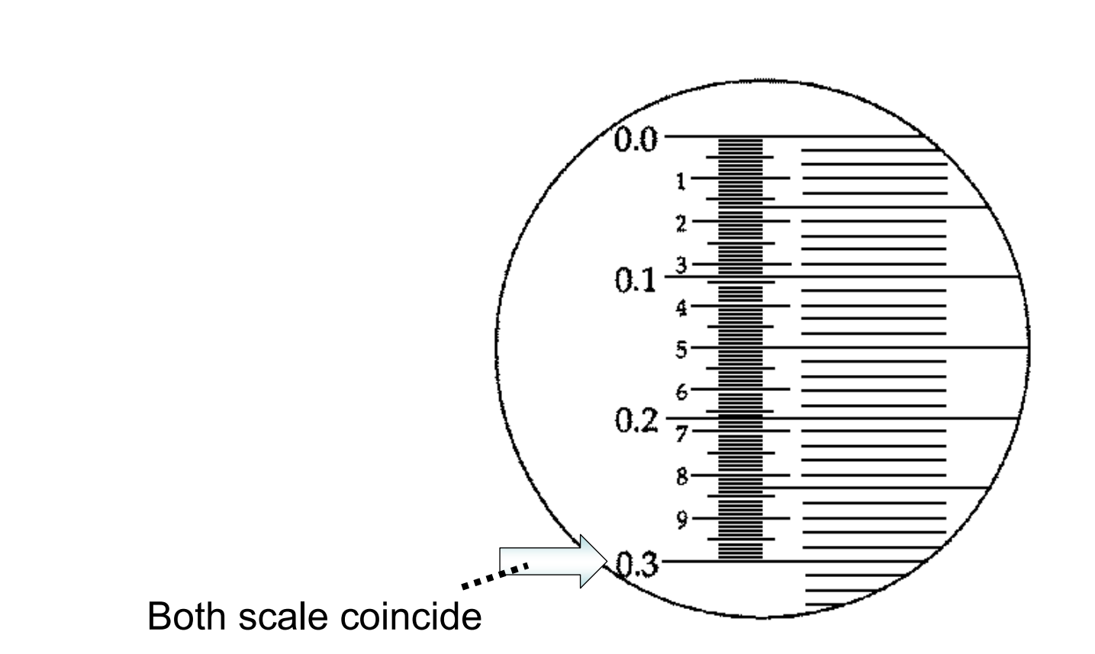 



**D．With the given slides, observe and draw the respective morphology of H9c2 cells and leukocytes.**

1. Place the slide of cells on the microscope stage and focus on the cells under **40X**

high-dry* objective,

2. **Draw the morphology on the Datasheet. Label nucleus, nuclear membrane, cytoplasm, and cell membrane in your drawings.**

**E. The hemocytometer**

1. HL-60 cells (human leukemia cells) in cultured medium are provided in a

microcentrifuge tube with unknown cell density.

2. Obtain uniformly suspended cells by **inverting the tube several times.**

3**. Load both counting chambers with the cell suspension using a micropipette and tip.**

Approximately **10 ul** will be required for each chamber. Place a **coverslip** over the

counting chambers of the hemocytometer allow the cell suspension to fill the space

Note: Fill the entire volume of the chamber but do not overfill!

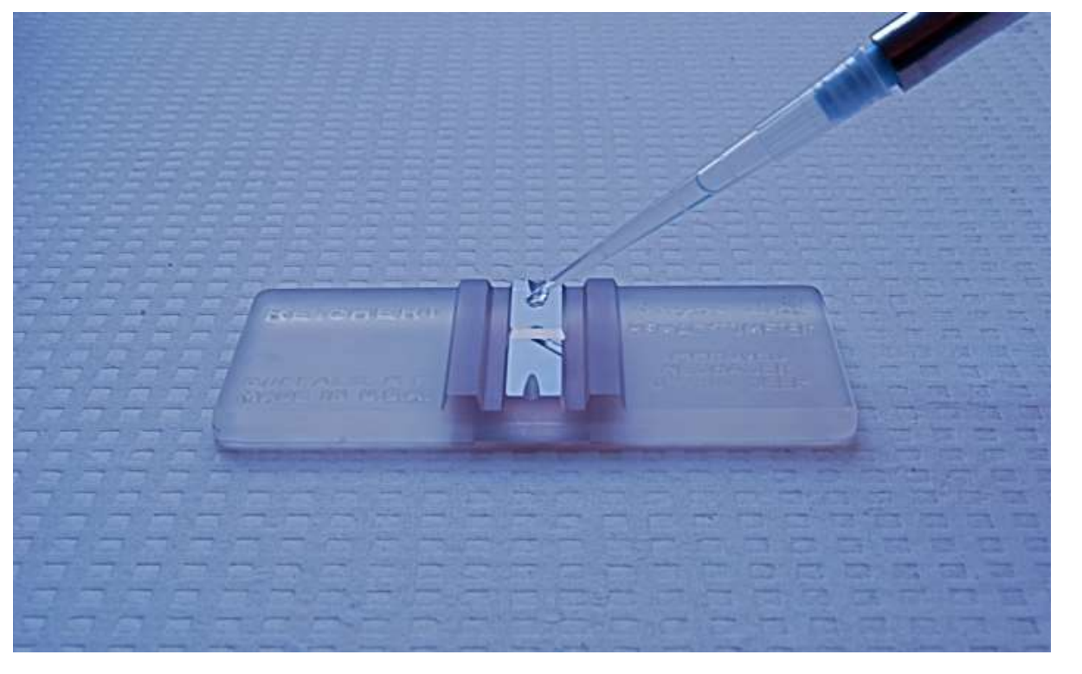

4. **Wait for a while** until the cells stop drifting around inside the chamber.

5. **Determine the number of cells** by viewing the cells under a **microscope at 100x**

magnification. Count all of the cells contained within the **four large squares labeled**

**as A i**n Figure 3 (count only those cells on the lines of two sides of the small squares

to avoid counting cells twice). You are required to count both of the chambers on the

hemocytometer.

Note: Always lower the stage before inserting a hemocytometer. It is much thicker

than any ordinary microscope slide.

6**. Calculate the cell concentration (number of cells/ml) on the Datasheet accordingly.**